**Database Tables**

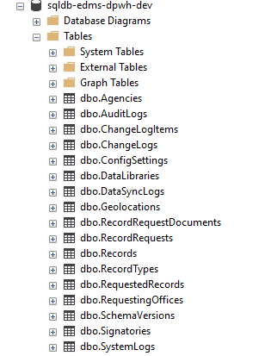

**Audit Logs**

**System Logs**



